Here is the menu of homework tasks for this term. You are not expected to do all of the activities, but choose areas of learning that interest you and your child.

Thinking skills  Can you explain what life in Egypt would be like without the River Nile? What benefits does the River Nile bring to life in Egypt? | RE  We are learning about Hinduism this term.  Many celebrations are linked to light e.g. Hanukah, Diwali. In churches and holy shrines people often use candles when they pray.  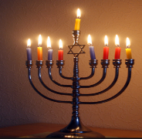  Design your own candle/candle holder (Diva/candelabra) to celebrate something that is important to you. | Geography  Imagine you are trying to persuade someone to take a holiday along the river Nile. Design a poster to sell your trip!  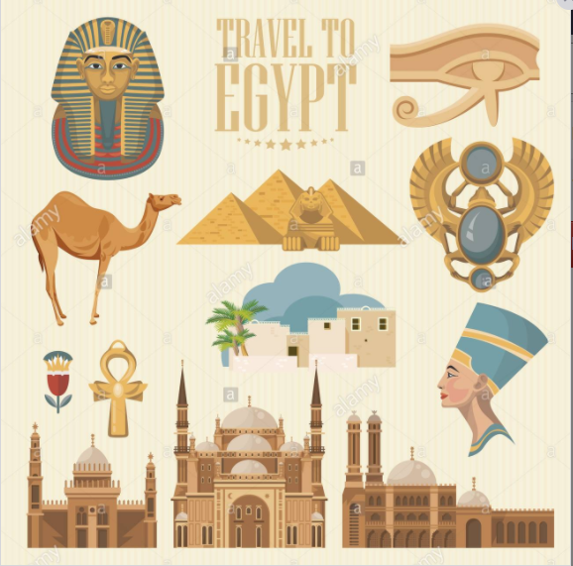
Reading  Extreme reading  Can you take a photo of yourself  reading in the most extreme place you can think of?  Miss Bolton and the librarians will be putting the  best examples and the most original ideas  on display in our library!  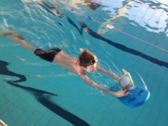  GET EXTREME READING! | Science/History In history we are learning about Ancient Egypt.  Discover the secrets and science of mummification.  Mummify an apple project  https://www.xplorationstation.com/stories/diy-science---make-a-mummified-apple  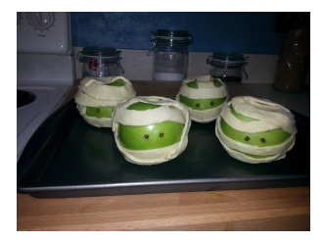 | ICT https://code.org/dance  1https://studio.code.org/s/aquatic/lessons/1/levels/1  Find out how to use coding to go on an aquatic Minecraft adventure  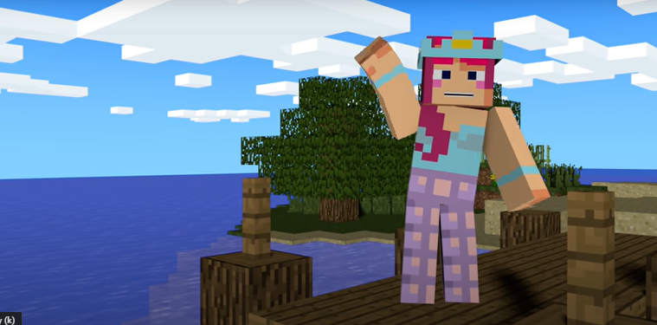
Maths
We would also like you to practise all timetables to 12x12 and related division facts to improve your recall speed. Log on to https://play.ttrockstars.com/auth/school/student/22769
Your child will also be set additional homework on Purple Mash, your log in will be reissued
Your homework is due on 14th October 2021
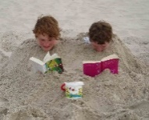
As you have several weeks, we expect your homework to be well presented. Parents - Please support your child to further their understanding of their learning and also in choosing and completing their homework to a high standard. You may wish to send in a photo of any models/art work created if it is not practical to bring it to school.

