

Homework Year 3/4

This term we would like your child to complete weekly homework for spellings, maths and reading. We have also given them one creative task to complete over the term if they wish.

Maths
Each week, we would like your child to login to TTRS and MathShed so they can practise their xtables and their rapid recall of number facts.


https://ttrockstars.com/ https://play.edshed.com/en-gb

Spellings
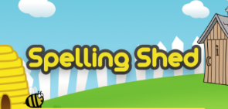
Your child is given a list of spellings to learn every week and you will find a copy of the list of words in their red spelling book. Some of the words follow a spelling rule or pattern whilst others are taken from the statutory year 3-4 . Your child’s weekly words are also put onto the SpellingShed websbite where they can practise them within a range of games!

https://play.edshed.com/en-gb

Reading
We would like your child to log in to myON, read some books within their specific ZPD range and quiz regulary.

https://www.myon.co.uk/login/

We recommend that children practise their maths, spellings and reading, in regular, short sessions every day. Your child’s class teacher will monitor the amount of time, games and quizzes that your child completes and they will be rewarded with House Points to reflect how they have engaged with each aspect of the homework we have set for them.
Creative Task
In year 3 and 4 we will be being rock detectives on the 10th and 11th March 2022. We would like you to do some more detective work and be creative.
You could make your own fossil https://youtu.be/EMdN5nNMtCo or https://youtu.be/rj_W6k6Y7-4
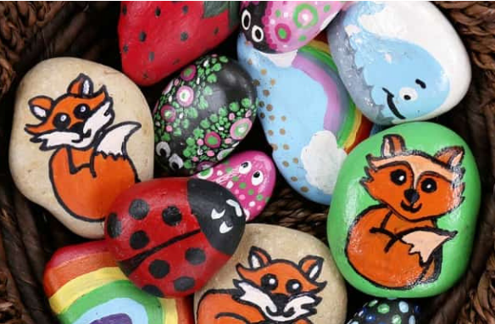Design a piece of rock art. Design a piece of art work or rock sculpture using rocks and natural objects.
This piece of homework is due on Thursday 7th April 2022

