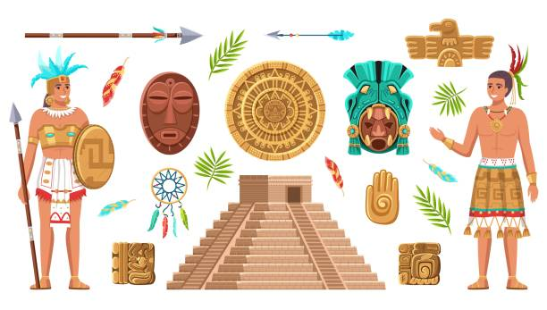
As historians and geographers we will…
Review primary and secondary resources to retrieve historical information. We will explain who the Maya people were and why they settled in Central America. We will identify and recognise different Maya gods and understand why religious ceremonies were important. We will understand the achievements of the Maya Civilisation and how they helped to move civilisation forwards.
Summer Term Curriculum Map
Year 5 and 6
As writers we will…
Year 5 - Use the Shakespeare classic Macbeth to write for a range of genres including a letter, a diary, setting descriptions and a newspaper report.

Year 6 - Explore and write a range of fiction and non-fiction text types. We will continue to extend our understanding of purpose and audience, adjusting our formality and style appropriately.

As scientists we will…
Investigate how light travels, what light is made up of and how we see colours and shadows. We will also learn about reflection and refraction and create our own periscope.
As designers we will…
Explore ways in which the Mayans created objects like blankets and God’s Eyes and have a go at using a loom and weaving techniques to create our own examples.

As mathematicians we will….
Year 5 – Build upon our knowledge from Year 4 about shapes and properties of shapes with links to our previous unit, angles. We will also be looking at strategies for multiplying and dividing by 10, 100 and 1,000 as well as negative numbers and conversion of units of measurement.
Year 6 - Continue to learn about fractions, decimals and percentages, developing our fluency, problem solving and reasoning skills. We will also look at solving a range of mathematical investigations with multiple steps.
As PSHE learners we will …
Year 5 – Look at how you as an individual view yourself and how that impacts on the friendships you choose. We will look at what is considered to be a healthy friendship and things that sometimes can lead to problems in friendships.

Year 6 – Discuss how control and power can affect different types of relationships. Using Michael Rosen’s Sad Book, we will learn about what if feels like to lose somebody close to us and the five stages of grief.

In RSE we will…
Year 5 – Discuss our own self-image and learn about the changes that occur during puberty for boys and girls. We will also learn about sexual intercourse and how this leads to conception and babies being made.

Year 6 – Discuss our own self-image and learn about the changes that occur during puberty for boys and girls. We will also learn about sexual intercourse and how this leads to conception and babies being made as well as the stages of pregnancy and giving birth. We will also be discussing physical attraction and relationships.

As religious scholars we will …
Explore the issues of fairness, equality, justice and poverty. We will learn about those who have challenged stereotypes and stood up for people’s rights throughout history. We shall also look at the idea of charity - charitable people and organisation. We will write our own mission statement/prayer to rid the world of poverty – a world with justice, equality and fairness.

As athletes we will…
Develop our striking and fielding skills in a range of activities and games.

YEAR 6 ONLY:
In preparation for secondary school, we will…
Learn about the risks and consequences of knife crime and how to avoid peer pressure.

We will engage in a range of transition lessons, helping us to prepare for the changes of secondary school.

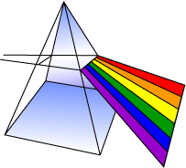
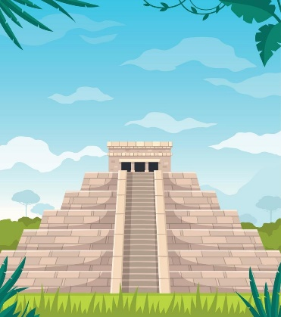
Using technology we will …
Learn how to create a range of interactive quizzes that requires the player to search a database.

We will also participate in the ‘First Phone Project’ learning about online safety through a series of lessons and VR technology.

YEAR 6 ONLY:
As performers we will…

Develop our singing, acting and dancing skills to put on an amazing Y6 leavers’ production!

Performances will be on Thursday 3rd July at 9:30am and 6:00pm.

