

Healthy, Happy Hearts & Minds –
Physical Activity & Well-Being @ Home

Sport England have put together lots of different ideas on how to stay active in and around your home. From dancing with the kids through Change4life 💃 to online home workouts 📺. There’s lots to choose from to keep things interesting. Visit https://www.sportengland.org/news/how-stay-active-while-youre-home for ideas.
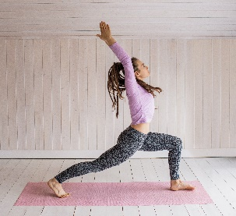
If you participate in any local physical activity groups or sessions, please contact your instructor as they may have alternative resources available including home videos to continue with your workouts at home.

Top tips to stay active at home:
- Create your own or access online home workout videos 📺
- Get ahead of the summer gardening 🌱
- Set up circuit stations around the house using everyday household items such as chairs, stairs and different items.
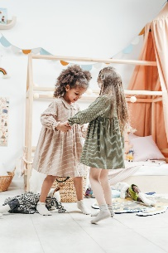
- Get out in the fresh air for local walks if it is safe to do so 🚶‍
- Use active console games if available such as wii, kinect and switch but only for a limited time e.g. 1 hour a day.

Change4life and Disney have teamed up and created Disney inspired 10 minute shake up games. These 10 minute bursts of activity will get the kids moving and count towards the 60 active minutes they need every day. Visit https://www.nhs.uk/10-minute-shake-up/shake-ups to take part.


If you’ve found great ways to keep active at home, tag @leicesterssp in your videos along with #StayInWorkOut to share your ideas with others. 📱

The NHS have created a selection of 10 minute workouts which are equipment free and great to do at home to easily fit into your routine. Visit https://www.nhs.uk/live-well/exercise/ to try them out. 💦
Joe Wicks – You Tube videos from kid’s workouts to HIIT sessions and more all using limited equipment in a small space (https://www.youtube.com/user/thebodycoach1)

You Tube – home workout videos

Go noodle - https://www.gonoodle.com/

Cosmic Yoga, great for well-being - https://www.youtube.com/user/CosmicKidsYoga

Other Ideas:

- There are some free Jump Start Jonny movement videos you can access on YouTube
- Create an obstacle course at home or in the garden.
- Build a den in your bedroom or garden but don’t forget to tidy up afterwards!
- Practice your rolling, aiming and throwing and catching skills. If you don’t have a ball use a pair of rolled up socks.
Basic Shapes in Gymnastics
- Practice the basic shapes in gymnastics and create a short sequence.
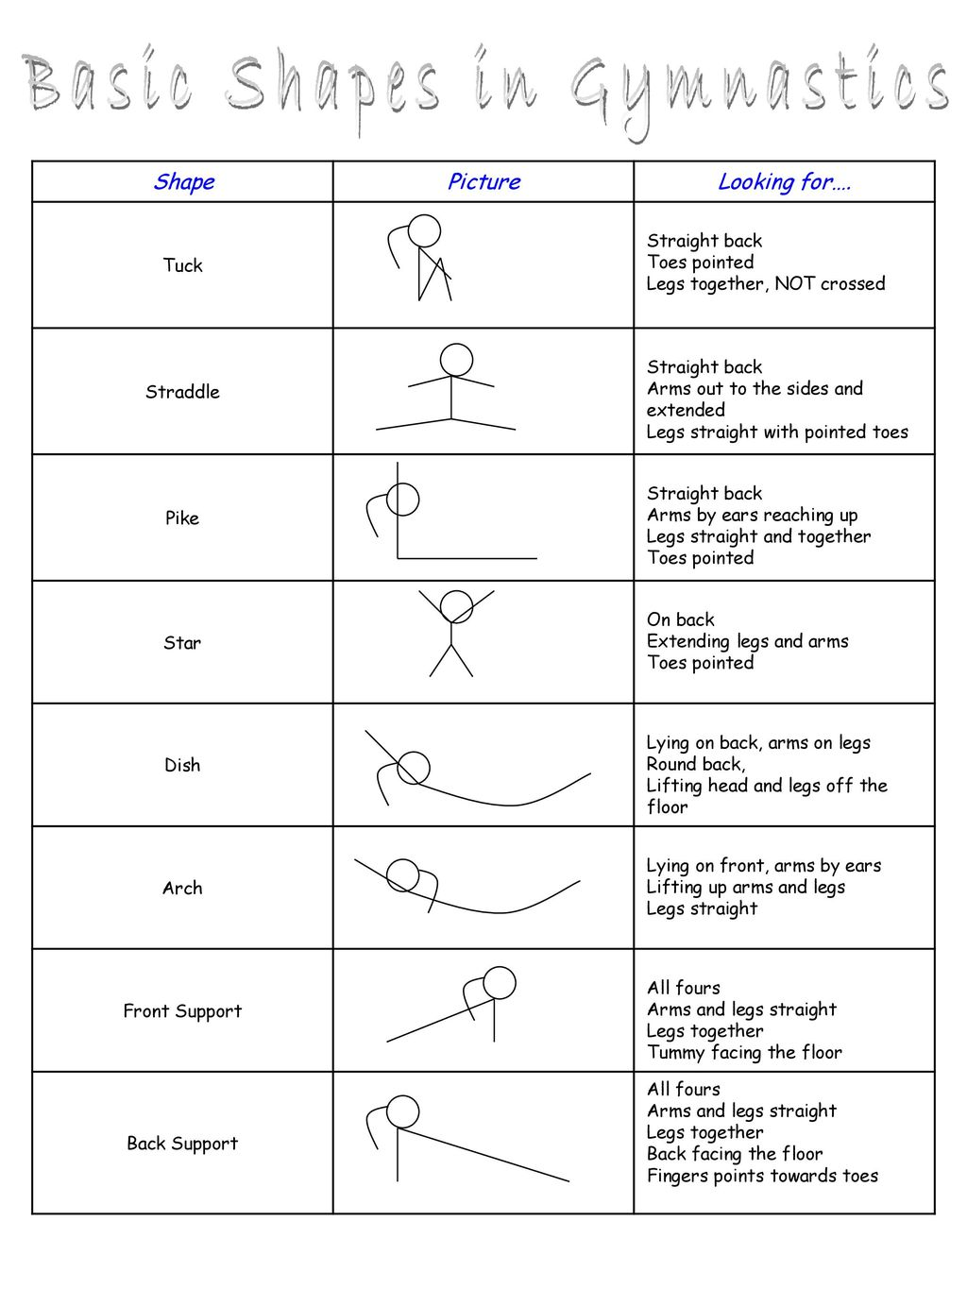
Continued……….



