

Geography
Vision
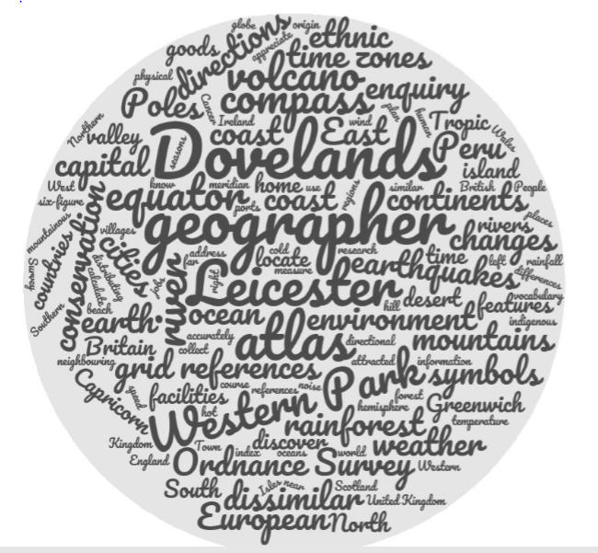
Earth is our home in space, a unique speck in the unimaginably vast cosmos and the only planet in our solar system capable of supporting life as we know it. Our planet provides us with all our needs today and our actions will influence its future survival. We live in a time of increasing globalisation and geography helps to explain how we are connected. At Dovelands we aim to develop the children’s love for the world around them through geographical enquiry - inspiring curiosity and fascination in the Earth and their place in it for many years to come.

Intent
We will follow the programmes of study of the National Curriculum for Geography. Our fully inclusive teaching equips pupils with knowledge about places and people, resources in the environment and an understanding of the interaction between physical and human processes that have shaped our landscape and environments. We strive to create a supportive and collaborative ethos for learning by providing investigative and enquiry based learning opportunities.
Powerful geographical knowledge, understanding and skills provide the framework to explain how the Earth’s features are shaped, interconnected and change over time. We want the children to develop geographical skills: field work studies, reading geography books, collecting and analysing data, using maps, atlases, globes, aerial photographs and digital mapping to name, identify and locate countries, continents and oceans. We want the children to be able to communicate their learning in a variety of ways including sketch maps with a key and diagrams, tables and graphs and creative writing. We want the children to love learning about geography both inside and outside the classroom. We don’t just want to take them around our local area. We want to take them to a volcano, the source of a river, Peru, Leicester of the past and many more places and times.
We are citizens of our diverse local area and of the world: Investigating and make enquiries about their local area of Leicester is vital so that they can develop a sense of who they are, their heritage and what makes our local area unique. Children will also look at the contribution they can make to our planet. Linking closely with the work of our Eco Warriors, children will appreciate and understand the environment directly around them and in different places around the world and they will know the importance of preserving our planet through the learning of physical geography. Children are encouraged to be eco-friendly members of society and as geographers, they will be pro-active and help protect our environment and celebrate our planet. They will express well-balanced opinions, rooted in a good understanding about the current issues in society and the environment.
Implementation
Geography is taught in all Key Stages on a two-year cycle. It is taught as a half-termly topic so that by the end of each year, three geography based topics are studied. Each topic will teach the children locational and place knowledge, aspects of human and physical geography as well as developing a range of geographical skills and fieldwork. The curriculum is designed to build on the children’s prior learning and personal experiences - to engage learners - and to widen their knowledge of world from their immediate surroundings and locality to countries in Europe and in other continents. Teachers plan by creating medium term plans from the Geography Long Term Map with a clear focus on the progression from the End of Key Stage Expectations. Teachers are to identify gaps in learning and misconceptions and encourage children to do the same as they become inquisitive and resilient learners.
Geography provides excellent opportunities to enhance the learning of more able pupils through the investigations, analysing sources and writing extending pieces. It also allows children with SEND needs to flourish through the variety of teaching and learning styles available to them. Reading is at the heart of Dovelands Curriculum and in Geography the value and love of information books is celebrated.

Impact
Geographers who ask and answer questions: where things are located on the surface of the earth, why they are located where they are, how places differ from one another and how people interact with the environment. All children will have worked towards achieving their end of Key Stage Expectations and have a rich geographical vocabulary. Pupil books, displays and interviews celebrate the broad, balanced and progressive teaching and learning styles. By the time they leave Dovelands we want our children to have enjoyed learning about geography and be equipped with necessary geographical skills and knowledge to enable them to be ready for the curriculum at Key Stage 3 and beyond. Moreover, we are looking to give children the fascination with the world we live in and understand the importance of caring for our often fragile planet. The study of geography at Dovelands will deepen their knowledge of the places and peoples from Western Park, Leicester to across the world and encourage them to explore, ask questions and undertake new experiences both now and in the future as life-long learners. When a Dovelands child leaves our school they will not say they ‘did’ geography, they will say… ‘ THEY ARE GEOGRAPHERS’

