

Reading
Intent
Reading is at the heart of our curriculum and we are dedicated to enabling pupils to become enthusiastic, motivated and lifelong readers. Through exposing our children to a range of high-quality texts, we intend for all our children and staff to develop the habit of reading widely and often, for both pleasure and information. Promoting discussions around books and authors, helps our children and staff to share their passion for reading, helps children to develop their comprehension skills and helps to fuel their imaginations for ideas to use in their own work. Teaching children to read for meaning from an early age allows for better comprehenders who are more likely to be motivated readers throughout life. Reading for pleasure is beneficial not only for reading outcomes, but for wider learning enjoyment and mental wellbeing, therefore we work hard to foster a love of independent reading. We believe reading is the key for academic success and know it is essential that, by the end of their primary education at Dovelands, all pupils are able to read fluently, and with confidence, in any subject in their forthcoming secondary education.

Implementation
In Key Stages One and Two, reading is discreetly taught through shared and guided reading over a two-weekly cycle. In whole class shared reading, a key skill is modelled by the teacher which is then practised by the children both with adult support and independently in a series of subsequent guided reading sessions. The key skills taught in these sessions cover the objectives set out in the National Curriculum as well as the strategies that educational research has found make a good reader.
The following aspects of reading are covered in these sessions:
- Word reading
- Wider decoding skills
- Grammar for reading
- Wider comprehension strategies
- Response to text
Shared reading sessions are structured as follows:
- A rich, challenging text is shared with the children. Where possible, the text is taken from the class read aloud book or the book being studied in English lessons
- Teacher explicitly models the key skill by voicing reader ‘think alouds’
- Children are then given the opportunity to apply the skill in mixed ability pairs
- Children discuss their application of the strategy
- Teacher listens in on the mixed ability pairs in order to undertake AFL.
Guided reading sessions are structured as follows:
- Teacher works with small groups of children of similar reading ability
- Children read a text at instructional level
- The focus taught in the shared session is reiterated and modelled again by the teacher
- The children apply the skill whilst reading quietly/silently at their own pace whilst teacher listens to each child independently
- Teacher assists children in applying the focus on a 1:1 basis.
- At the end of every guided reading session, a statement or question (talking point) is given to the children about the text they have read to form a discussion amongst the group. This not only gives the children an opportunity to develop their oracy skills, but also allows the teacher to assess the children’s overall understanding and comprehension of the text they have read
- The groups of children who are not reading with the teacher; practise and apply the same skill independently using a book at their level; are given the opportunity to read for pleasure; access the online reading platform ‘myON’
- Children who are identified as working below ARE are given an extra guided reading session throughout the cycle. This session could be used to focus on a wider decoding skill which is relevant to that group

The progression of reading is mapped out in a variety of ways. To ensure that an appropriate pitch and expectation in reading is being planned for, the Profile of Achievement in Reading pro-forma, which contain the Parks Progression Statements, show the key skills that are taught in each year group.

- In Key Stage One, a greater emphasis is placed on the teaching of word reading objectives with a lesser proportion of sessions dedicated to wider decoding skills, comprehension strategies and the children’s response to text.
- In lower Key Stage Two, a greater emphasis is placed on the teaching of comprehension objectives with a lesser proportion of sessions dedicated to word reading, wider decoding strategies and the children’s response to text.
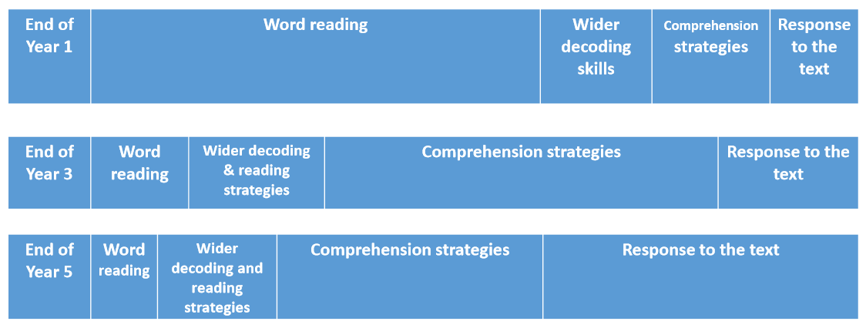
- In upper Key Stage Two, a significant proportion of sessions are still spent teaching comprehension strategies, as well as a similar proportion being spent developing children’s response to text. A lesser proportion of sessions are spent on word reading and wider decoding strategies. However, the exact proportion of sessions will be dependent on the assessment of children’s abilities and needs.

The pitch of texts, as well as the genre of texts used for shared and guided reading sessions, also ensure progression. All fiction books in school are finely levelled using both the AR system that is determined by the ATOS formula, and PM benchmarking levels. This means teachers and children are fully supported when selecting books at the correct level. Year group long term plans and overviews for reading ensure whole texts are used where possible for both shared and guided reading including a range of fiction, non-fiction and poetry.
Reading is an integral part of daily life at Dovelands and as well as being taught discretely, it is interwoven throughout all curriculum areas. English lessons, other curriculum subject lessons, when visiting the library or reading the class book at the end of the day give further opportunities for teachers to expose the children to a range of high quality texts types whilst promoting reading for pleasure. It also allows teachers to recap, consolidate and fully embed previously taught reading strategies.
The novels chosen for use in English lessons and those which are chosen for class books are mapped out to ensure progression on an instructional level as well as the themes which they cover. We also ensure that all the high quality books and texts we read and share with our children either for pleasure or for academic purposes include a mixture of male and female protagonists and reflect the different cultures in our school and wider community with books that feature BAME characters and written by BAME authors. Our poetry long term plans also ensure that there is a breadth of different types of poetry taught across the school, as well as a range of poets from different backgrounds.
Our school library and reading areas are well stocked and regularly updated, allowing children to immerse themselves in the wonderful world of books. The areas are stocked with an attractive range of fiction and non-fiction books which are often chosen by children. This ensures we support every ability and reading choice and gives the children a greater sense of ownership. The use of these resources is enhanced by the teacher’s knowledge of children’s literature and of their pupils as readers. Our regular staff book clubs ensure the teachers at Dovelands continue to develop their own subject knowledge of different books and authors in order to make appropriate recommendations to their children.
The reading environment that has been created throughout the school via corridor and classroom displays, poetry weeks, Our Best Book and Picture Book initiatives, World Book Day, various author visits and designated reading areas around school, have been designed to encourage a love of reading. Children are often actively encouraged to share their enjoyment of reading by drawing comparisons between the books and authors they have read as well as giving recommendations to their peers and teachers. This ensures the children become more aware of their own likes and dislikes, they widen their reading experiences of genre and theme in order to help them make more informed and adventurous choices when choosing their own books, and also to develop each other’s subject knowledge of suitable books and authors.

Impact
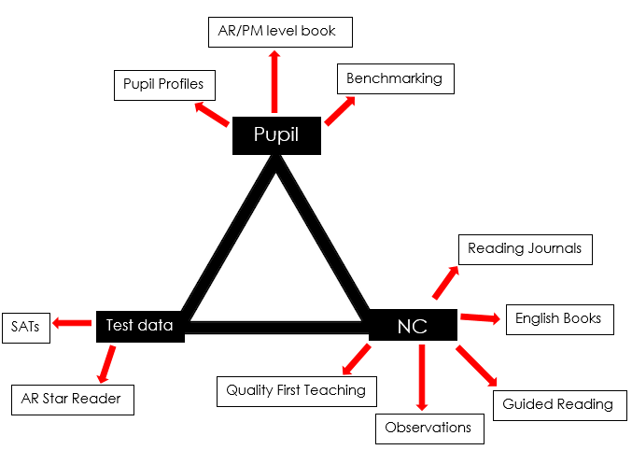
The impact of our curriculum is measured in many ways. Our Profile of achievement in reading grids, which are a simplified version of the progression statements, is used for assessing children’s reading. Reading judgements are secured through the triangulation of test data, evidence from the pupil and the curriculum.

Our test data comes from SATs and Accelerated Reader tests (AR quiz outcomes once a child has completed a book, and the termly Star Reader tests of which the children do at least 4 times a year). We also use benchmarking to agree a book level, with some being videoed for moderation purposes. Finally, evidence from the curriculum is also gathered from their reading journals, English books and guided reading session notes and any 1:1 reading the children may have had. Where children are found to be having difficulties with their reading, pupil profiling, which is an indepth comprehension assessment, is used to identify what might be causing the child’s difficulties in understanding the text. During pupil profiling, children will read aloud a short extract of text and answer questions based on it indicating which reading strategies they need to develop. Once a need is identified, the child will receive an appropriate intervention to address this.
Children achieve well at the end of both Key stages, as well as at the end of each year. The % of pupils working at ARE and Greater Depth within each year group is at least in line with national averages. There are some gaps in the progress and attainment of different groups of pupils (e.g. disadvantaged vs non disadvantaged, boys vs girls) which are addressed through actions linked to the SDP.
Children and staff at Dovelands read widely both inside and outside of school and enjoy reading across a range of genres. Confident discussions and recommendations means children and staff continue to widen their exposure and develop their subject knowledge of books and authors. Pupils are equipped to use a range of strategies to decode and comprehend texts so they are well prepared to progress through Dovelands and meet the needs of a challenging secondary curriculum and the expectations of reading across all subjects.

